**List of Bugs**

**“Fifteens” app**

1. In the application "Fifteens" on "Level 1" when a chip approaches the appropriate place when the chip is on the adjacent cell vertically - it is automatically set in its place.



2. Caption GL verts: 486

GL calls: 16

59.1 / 0.001" in the lower right corner of the "Fifteens" application overlaps the "Previus" inscription.



3. In the lower right corner of the Fifteens app, there is an error in the word "Previus" - the letter "o" is missing after the letter "i", the correct writing is "PreviOus".



4. When successfully completing "Level 1", a misspelled inscription in green appears at the top center of the Fifteens app - "Level pased", the letter "s" after "pas" is missing in the word "pased", the correct word is "passed".

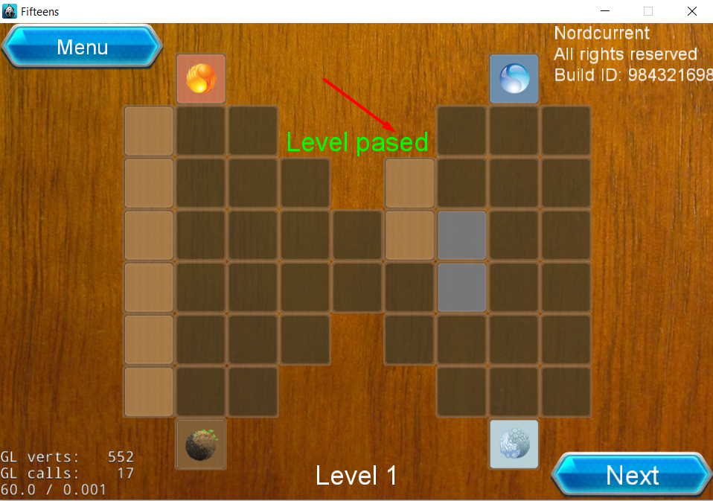

5. After successfully completing "Level 1" and moving to the next level - the progress of the previous level is not saved.



6. In the lower central part of the application the first letter "level 2" is lowercase, in the other levels the letter is capitalized.

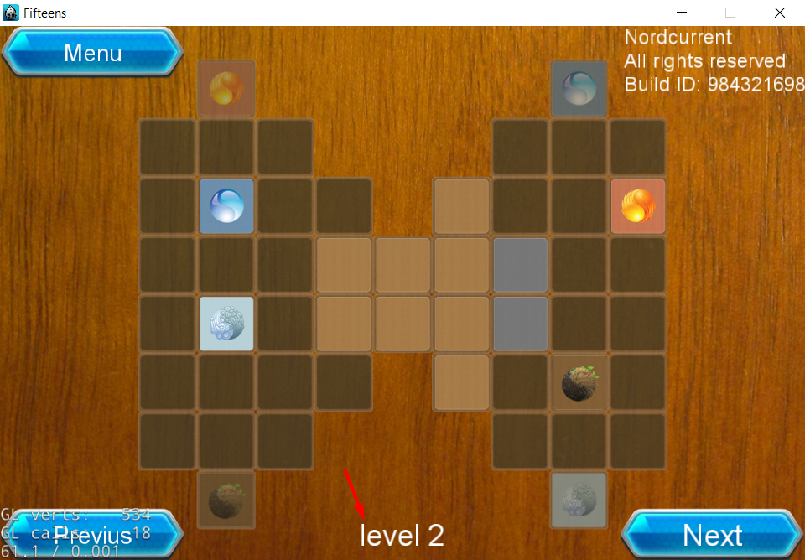

7. At "level 2" the left "translucent blue chip" and the right "brown chip" are placed in the wrong slot.



8. At "level 2" the left translucent blue chip and brown chip when installed in a slot that does not match it, in the adjacent cell vertically can not be installed any of the chips.



9. If you successfully complete "level 2", you will advance to "Level 4".

Level 3 is not available.



10. At "Level 4" in the lower right corner of the app, the "Next" button is not clickable.



11. When a "brown chip" is inserted in the corresponding slot, the Fifteens app unexpectedly closes.



12. In the right column, the two "empty blue chips" cannot be moved across the cells in all levels of the Fifteens app.

